Z-Match Kit Installation and User Manual

BI1GHZ 2023-04-13

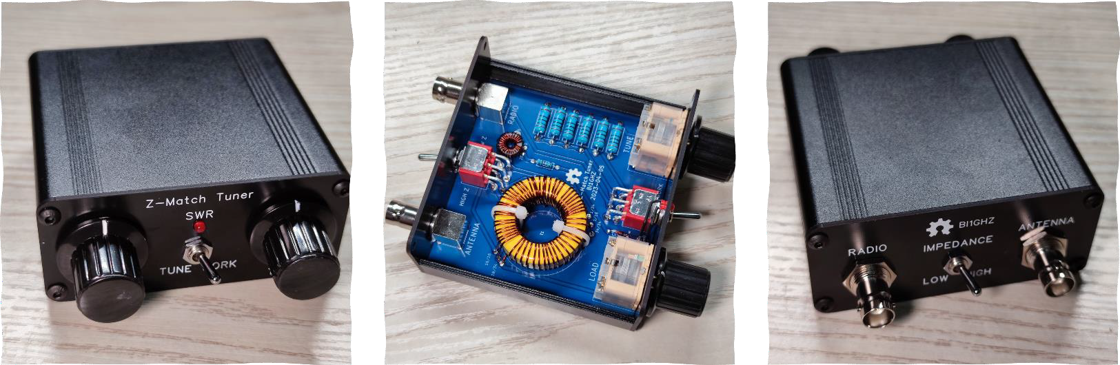

# Parts List

|  |  |  |  |
| --- | --- | --- | --- |
| examine | name | quantity | Position No. |
|  | Variable capacitor BM-443BF | 2 | C1, C2 |
|  | Extension rod 13mm | 2 |  |
|  | Screw silver round head cross M2.5×15mm | 2 |  |
|  | Screw silver countersunk cross M2.5×3 | 4 |  |
|  | Knob cap KYP25-18-6 | 2 |  |
|  | Toggle switch MT-0-202-A003-M003-RS | 2 | SW1, SW2 |
|  | RF Connectors BNC-KWE 50R | 2 | J1, J2 |
|  | resistance1W 1% 100Ω | 6 | R1-6 |
|  | resistance1/4W 1% 1kΩ | 1 | R7 |
|  | LED red3mm long pin | 1 | D1 |
|  | Diode 1N4148 Direct Plug | 1 | D2 |
|  | Ring Ferrite FT37-43 | 1 | L1 |
|  | Ring Ferrite T130-6 | 1 | L2 |
|  | Heat shrink tubingΦ0.6 6cm | 1 |  |
|  | Cable Tie 3×80 | 2 |  |
|  | Enamed wire diameter 0.4mm length 60cm | 1 |  |
|  | Enamed wire diameter 0.6mm length 30cm | 1 |  |
|  | Enamed wire diameter 0.6mm length 50cm | 2 |  |
|  | Enamed wire diameter 0.6mm length 90cm | 1 |  |
|  | Enamed wire diameter 0.6mm length 100cm | 1 |  |
|  | PCB blue | 1 |  |
|  | panelFR-4 material black 88×38mm | 1 Set |  |
|  | Panel aluminum alloy black 88×38mm | 1 Set |  |
|  | Chassis aluminum alloy black 88×38×80mm | 1 Set |  |
|  | Screw black round head hexagon socket M3×6 | 8 |  |
|  | Screw black countersunk hexagon socket M3×6 | 8 |  |
|  | Simple socket 10×55mm | 1 |  |

Installation Process

[ ] Try to Insert the PCB into the slot of the half chassis. If it is too tight, use sandpaper to slightly grind the left and right ends of the PCB. After making sure that the PCB can be smoothly inserted into the chassis, remove the PCB from the chassis.

[ ] Use a black marker to outline the front and back panels.

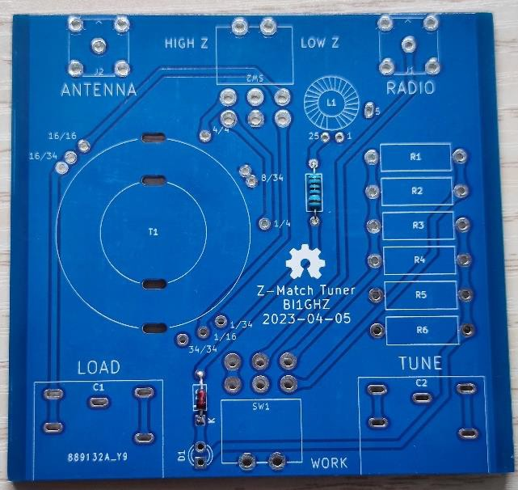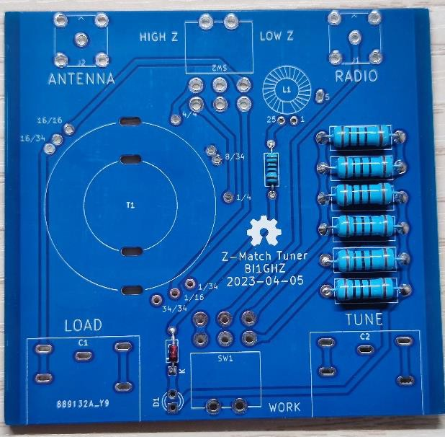[ ] Install diode D2 and 1/4W resistor R7. Note that the diode should be installed according to the silk screen direction.

[ ] Install 6 1W resistors R1-6. Elevate the resistors with a piece of wire so there is some airflow around the resistors.

Figure 1 Installing diode D2 and 1/W resistor R7 picture 2 Install 6 1W resistors R1-6

[ ] Preparing the winding coil L1. Use FT37-43 magnetic ring (black, about 1cm in diameter) and 0.4 mm-thick enameled wire.

[ ] First, go around 5 turns, leaving a piece of thread, and then wrap it 20 times. A total of 25 turns.

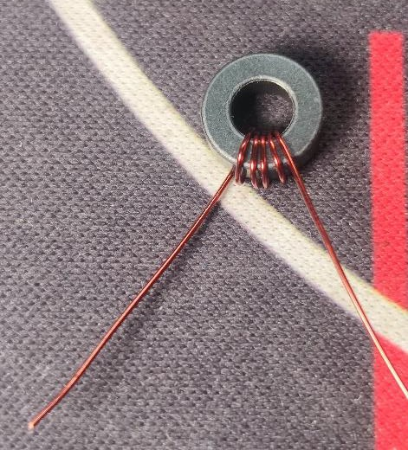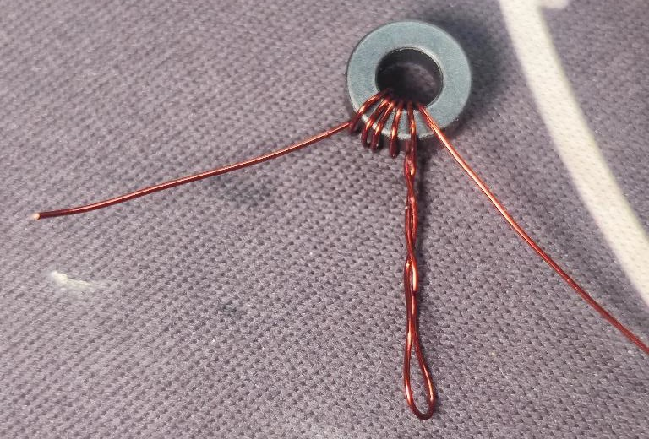

Figure 3 Coil L1: 5 turns picture 4 Coil L1: After the 5th turn, leave the thread and continue the 6th turn

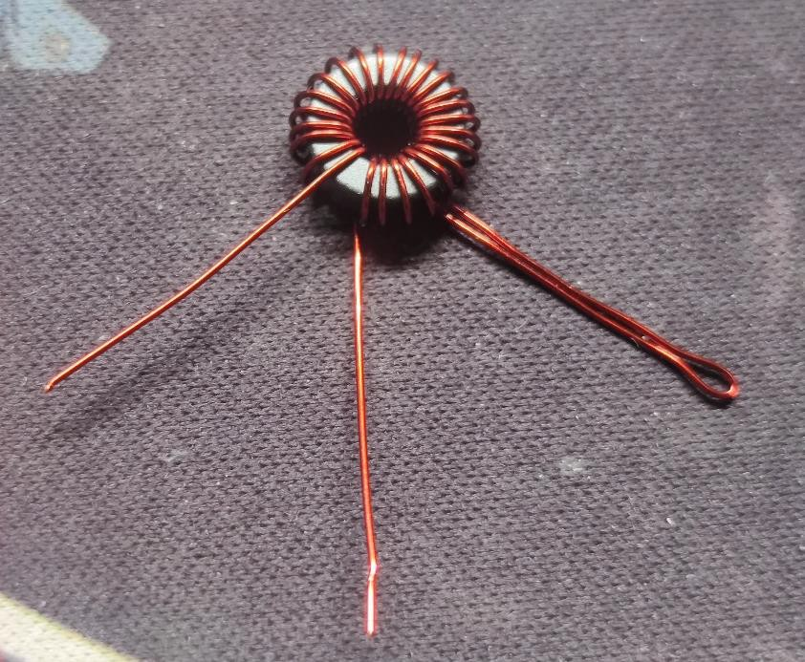

picture5 Coil L1: Completed, 25 turns in total

[ ] Scrape off the paint coating on the enameled wire at the three ends. Install L1 on the PCB and solder the wire ends.

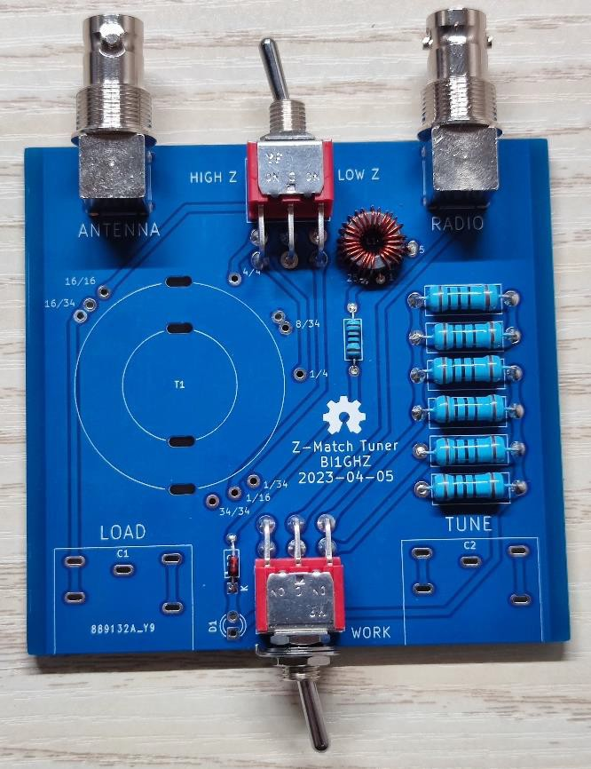[ ] Install BNC socket J1, J2 and toggle switches SW1, SW2.

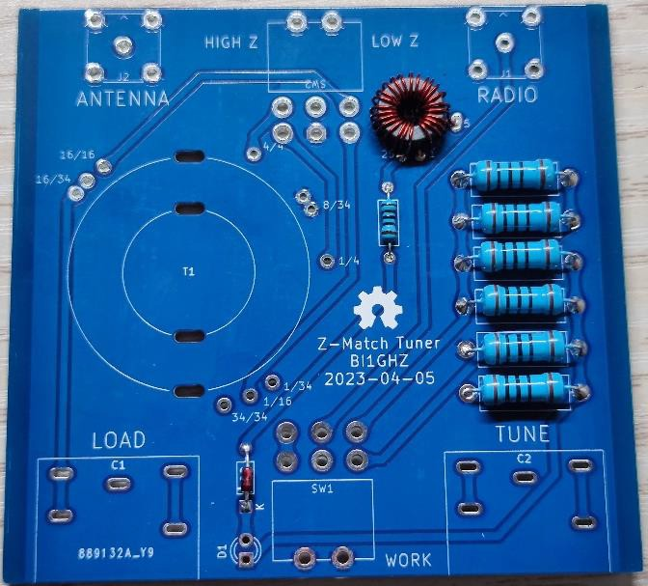

picture6 Install coil L1 on the PCB

picture7 Install the BNC socket and toggle switch

[ ] Prepare winding magnetic ring L2. Use T130-6 magnetic ring (yellow, about 3.3cm in diameter) and 0.6 mm-thick enameled wire.

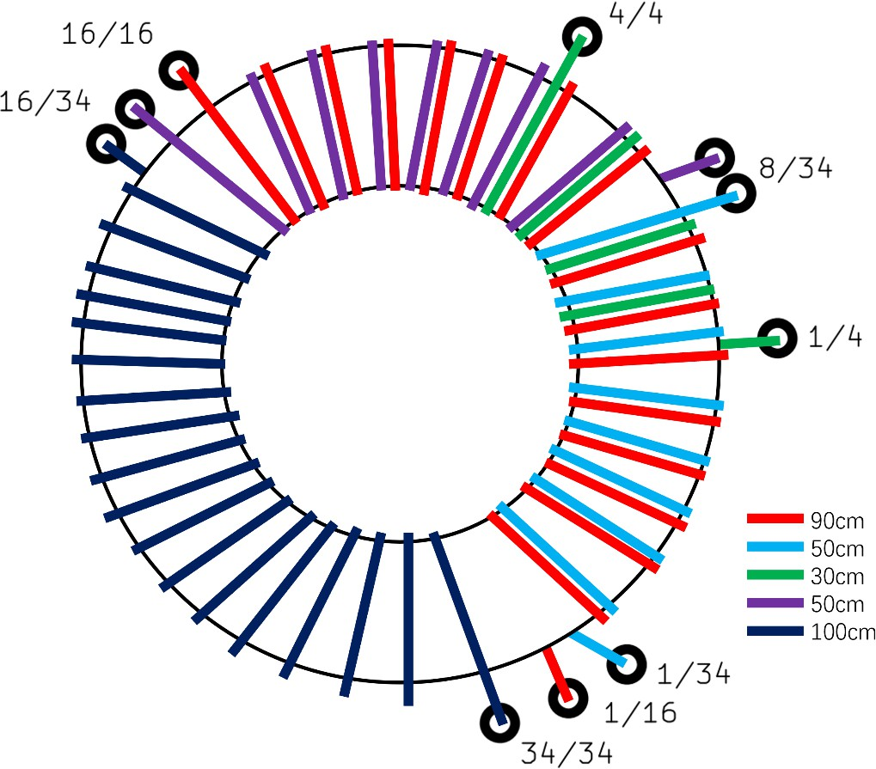

picture8 Coil L2 winding diagram

[ ] Find the length. Put the 50cm and 90cm enameled wires together and pass them through the magnetic ring (ie, the first circle in total), with the 90cm on the left and the 50cm on the right. Wrap the two wires together for 6 circles.

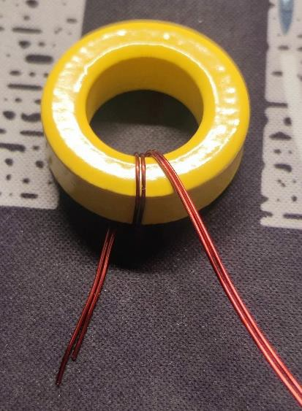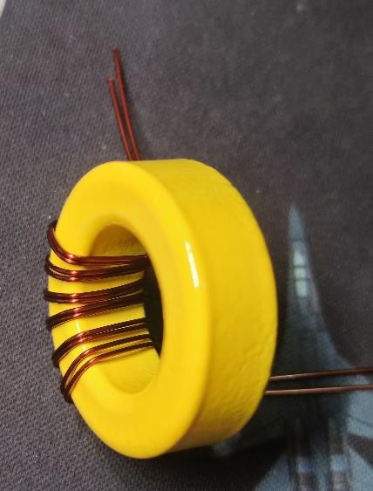

Figure 9 Coil L2: Two wires, when winding the second turn Picture 10 Coil L2: After winding the two wires 6 times

[ ] Two lines are wound again 1 circle (ie, 7 circles in total). Find a 30cm long enameled wire, pass it through the middle of the 7th circle of the previous two wires, and start its 1st circle. Then wrap the 3 wires around 1 more circle (ie, 8 circles in total).

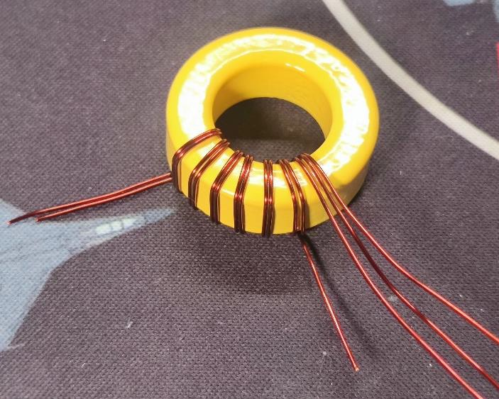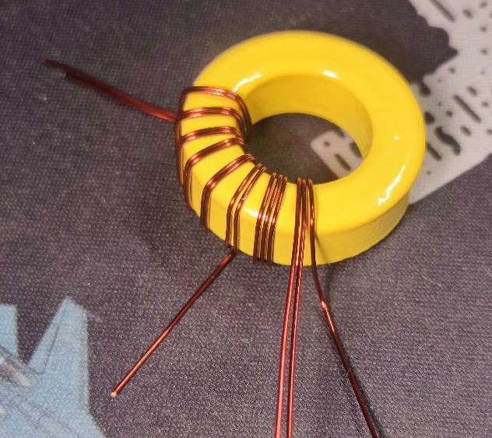

Figure 11 Coil L2: Introducing the third wire (the seventh coil in total) picture 12 Coil L2: 3 wires wound to the 8th turn

[ ]The right side of the 3 wires ends here. Find another 50cm enameled wire to replace it and continue winding 2 more times (the 10th time in total).

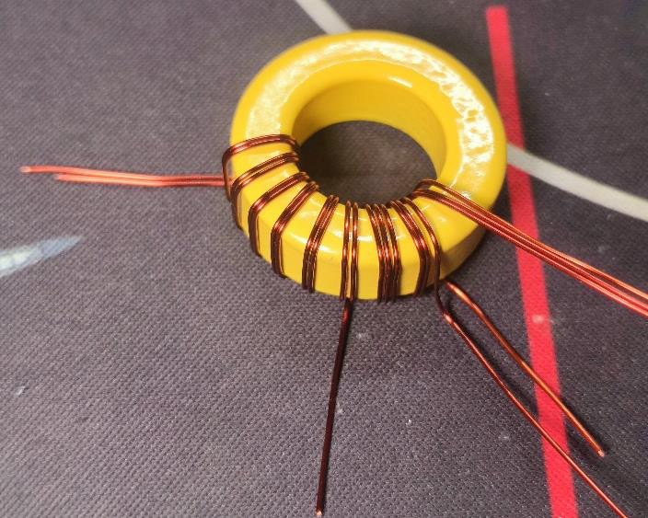

picture13 Coil L2: Replace the rightmost wire (9th coil in total)

[ ]The middle line of the three lines ends here, and the remaining two lines on the left and right continue to circle 6 times (16th circle in total).

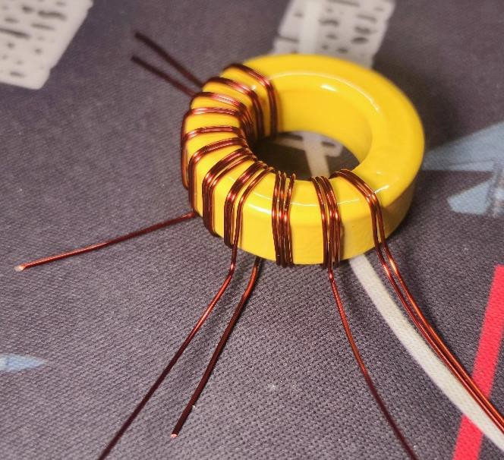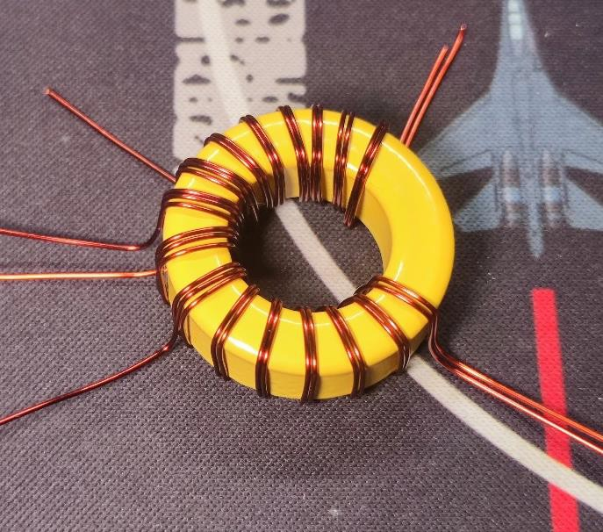

Figure 14. The middle line ends at the 10th circle, and the remaining two lines continue to wrap around the 11th circle Picture 15. Coil L2: Wind to the 16th turn

[ ]Both wires end here. Find 100cm of enameled wire and start winding 18 times from here.

[ ] Scrape off the paint coating on the enameled wire on the wire end. Cut the wire end into steps counterclockwise or clockwise to facilitate insertion into the PCB.

**Attention!** Before installing L2 on the PCB, be sure to perform a visual inspection to ensure that there is no cross-wrap of the enameled wires; be sure to perform a ring check to ensure that the order of the enameled wire ends is as expected.

[ ] WillL2 is mounted on the PCB, and the connector is soldered.

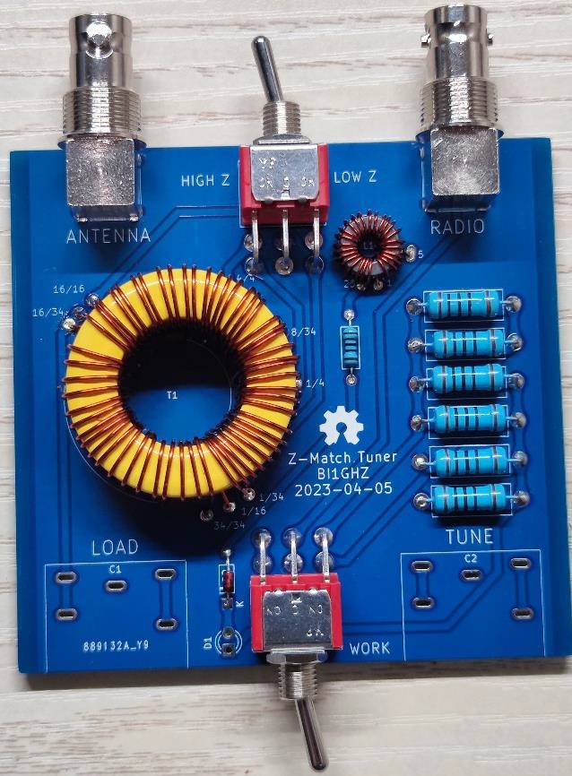

picture16 Solder the wound L2 to the PCB

[ ] Use the cable tie to pass through the mounting hole and fix the magnetic ring L2.

[ ] Use the extension shaft Use the M2.5×12 screw to fix the adjustable capacitor.

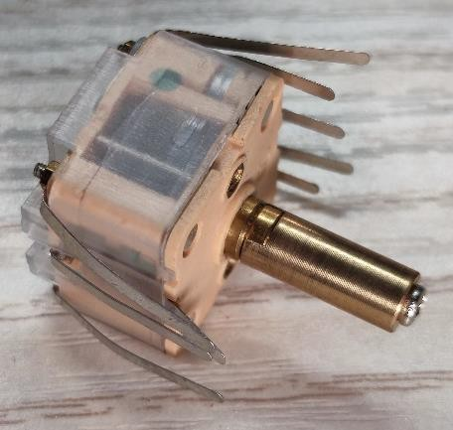

picture17 Install the extension shaft

[ ] Straighten the leads of the variable capacitor. 4 pins on the FM side, and 5 pins on the AM side are reserved.

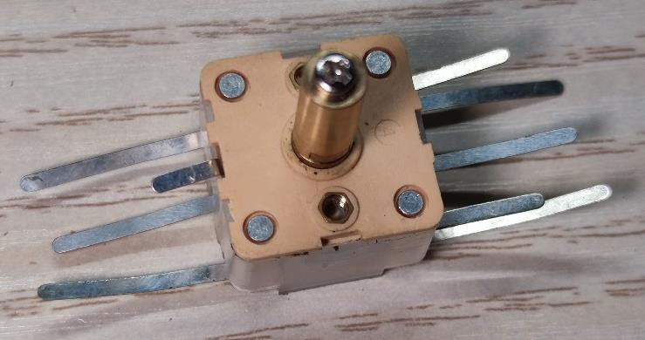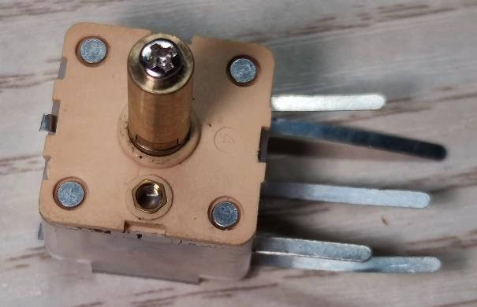

Figure 18: Straighten the pins Picture 19: **Cut off the unused pins**

[ ] Insert the variable capacitor into PCB, then fix the front panel to the toggle switch, and then fix the capacitor to the front panel with M2.5×3 screws.

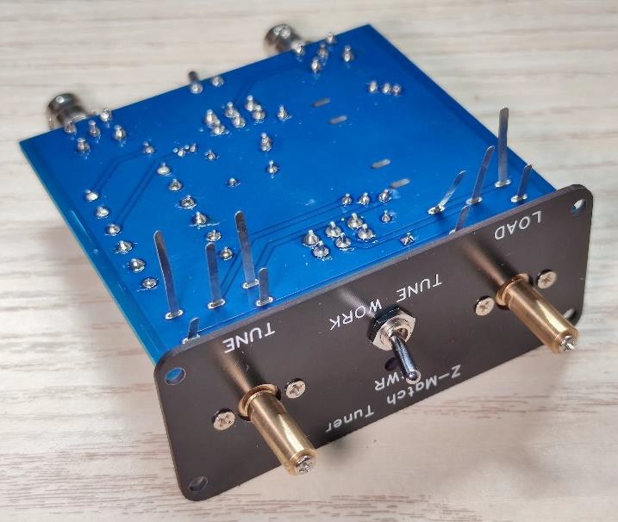

Picture 20: **Fix the front panel, the toggle switch, and variable capacitors before soldering**

[ ] Solder the variable capacitor.

[ ] Put the heat shrink tube on the LED pin and use a heat gun or lighter to make the heat shrink tube tightly attached to the pin.

[ ] Bend the two pins of the LED toward the short pin. At 1cm, bend the two pins downwards.

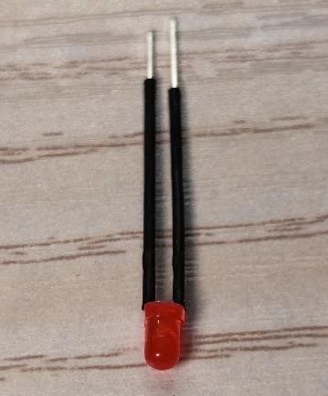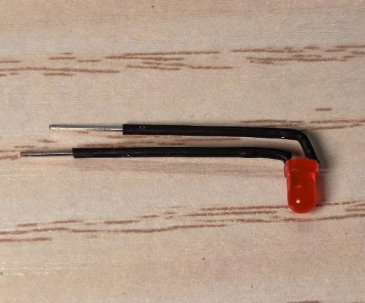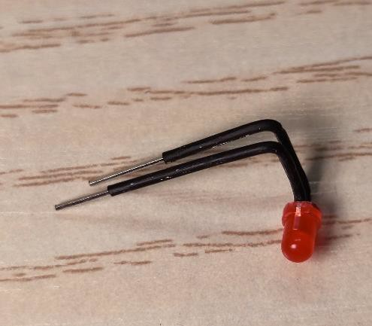

Figure 21: Put heat shrink tubing on the pins Picture 22: Bend the pin horizontally toward the short leg side Picture 23: Bend the pin downwards 1cm away from the lamp head

[ ] Insert the LED through the hole in the front panel and solder it to the PCB. Note that the short leg is on the square pad.

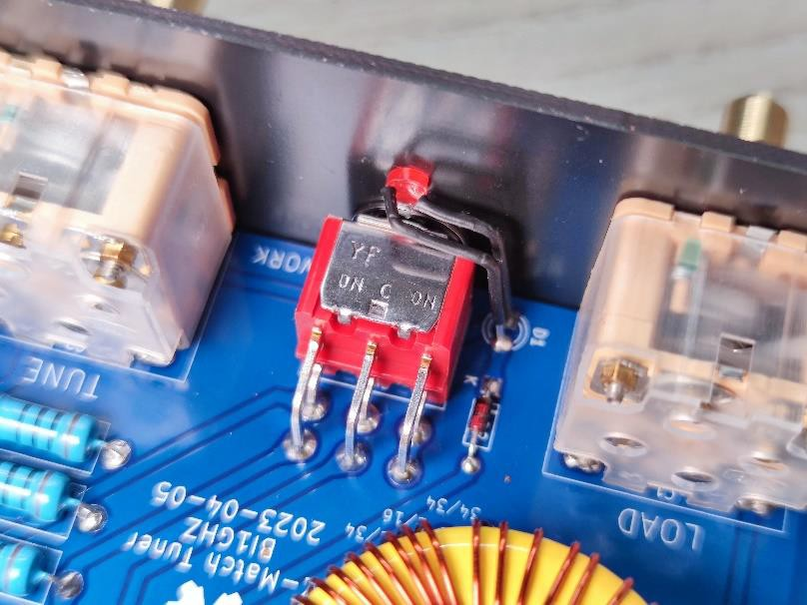

Picture 24 Installed LED indicator

[ ] Will insert the PCB (and the front panel) into the half chassis, and install the rear panel and the other half chassis in place. Fix the front and rear panels to the chassis with M3×6 round head hexagon screws, and fix the toggle switch, nuts of the BNC socket, and screws of the adjustable capacitor.

Tip: From the inside to the outside, the BNC socket consists of the BNC socket body, the panel, and the nut. No gasket is used.

Tip: The toggle switch from inside to outside is the toggle switch body, nut, gasket, panel, nut, and no fixing plate is used.

[ ] Remove the top cover of the knob cap, insert the knob cap onto the shaft of the adjustable capacitor, and then tighten the nut on the top of the knob cap with a simple sleeve and replace the top cover. Note that the rotation angle of the adjustable capacitor is 180°, so please adjust the direction of the scale line on the knob cap before tightening the knob cap.

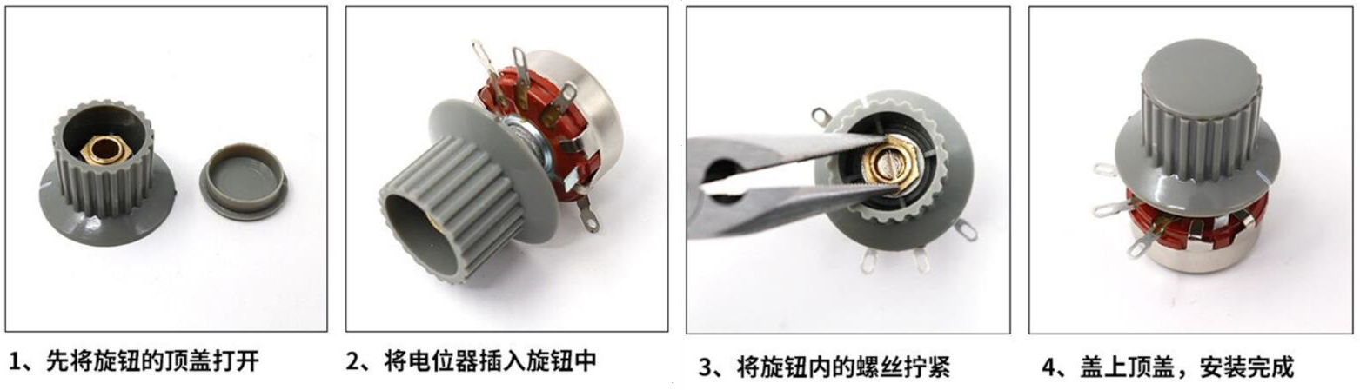

Different Style Knobs: Picture25 Schematic diagram of how to install the knob cap

The installation is complete. Try it now.

# Schematic

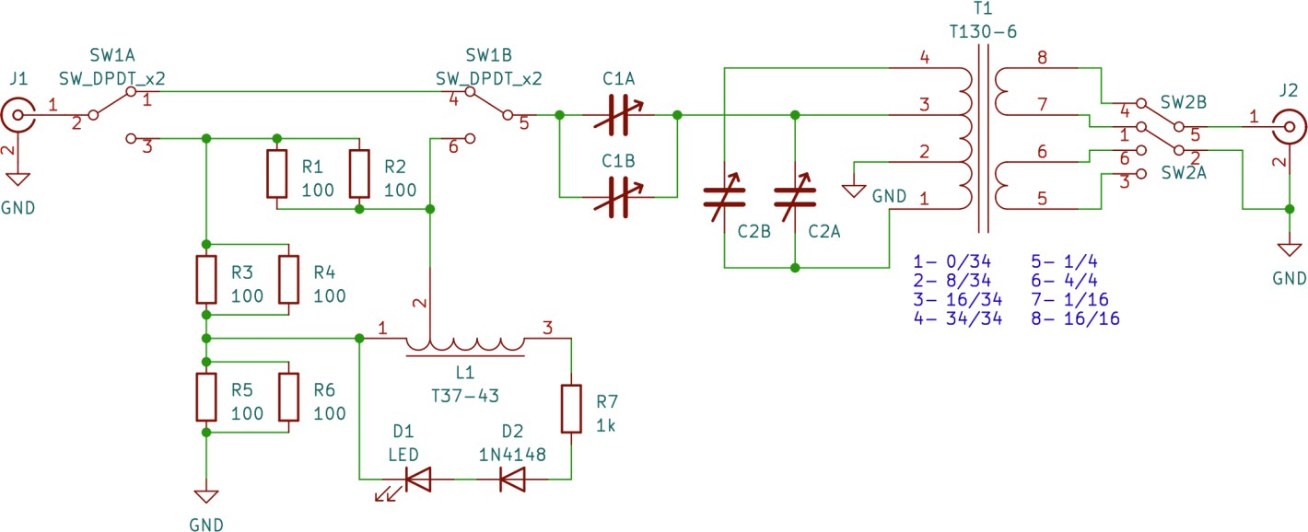

use

The front switch is used to set the mode. When it is set to TUNE, the standing wave indication circuit will be connected. When the transmitter is transmitting a signal, the brighter the LED, the higher the standing wave. The two capacitor knobs are used to adjust the matching. The rear switch is used to set the antenna impedance.

Note: Standing wave indicator LED

Note: Be sure to check the standing wave before transmitting; otherwise, the lack of high standing wave protection may burn out the QRP transmitter.

Note: If you cannot tune quickly, please use a network analyzer to debug. At this time, the mode switch should be set to WORK. Note: This antenna tuner is only suitable for QRP; excessive power may cause components to burn out.

# **Statement**

This project refers to I would like to express my gratitude to the DIY antenna tuners, such as ZM-4 and QRPGuys Multi Z Tuner.

This is an open-source hardware project released under the MIT license. Project files and documentation are published on GitHub and OSHW Hub.

